## **Fall 2025 Jewelry Trends: A Season of Style and Sparkle**

**With fall now in full swing, it’s time to explore this season’s biggest jewelry trends. Fall brings rich, warm shades of orange, red, and brown—and it’s the perfect time to refresh your look with new statement pieces. Whether you’re heading to a pumpkin patch, doing a photoshoot, or just enjoying crisp autumn days, these trends will keep you one step ahead.**

**At Drenon Jewelry, it’s our mission to bring your dreams to life—no matter the season. Here’s what’s trending this fall.**

### **Bold Pendants and Statement Necklaces**

**This year, bigger is definitely better. The jewelry world is shifting from dainty pendants to bold, artistic statement pieces inspired by modern design. These necklaces pair beautifully with fall’s muted color palette and instantly elevates your outfit.**

**For a night out or a fall gathering, a statement necklace is the perfect conversation starter—and a stunning way to stand out.**

### **Mixed Metals and Contrasts**

**Gone are the days when everything had to match. Mixing metals is now one of the hottest trends, adding depth and creativity to your style.**

**Try stacking yellow gold with silver or adding diamond accents for a touch of sparkle. Stackable jewelry—rings, necklaces, and bracelets—continues to dominate, offering endless combinations that work for both casual outings and special events.**

**We especially love this look for photoshoots and fall sporting events—it’s stylish, yet effortless.**

### **The Reemergence of Pearls**

**Pearls are back in a big way—but this time, they’re making a statement. Oversized and chunky pearl designs are turning heads as the focal point of modern jewelry.**

**Pair your pearls with yellow gold for a timeless yet trendy look. Elegant and versatile, pearls are perfect for everything from a pumpkin patch visit to dinner with friends.**

### **Layering Takes Center Stage**

**Layering jewelry has evolved into a true art form. What once meant stacking as many pieces as possible has become a refined, curated way to showcase your personality.**

**Here’s how to master the layered look:**

* **Have a focal point: Choose one standout piece—a pendant, bold chain, or statement ring.**
* **Vary lengths and sizes: Mix necklaces between 14” and 20”, stack slim bangles with a cuff, or pair statement rings with simple bands.**
* **Mix textures wisely: Combine chains, pendants, and finishes, but keep a consistent theme (for example, gold chains with silver accents).**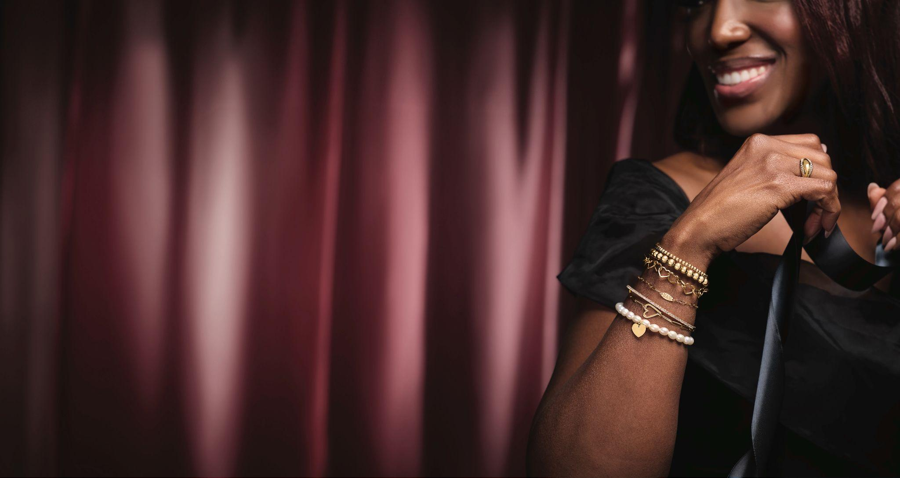
* **Stay balanced: Include more than one piece of each metal so no single color feels out of place.**
* **Keep it comfortable: Your jewelry should feel as good as it looks—if it’s not comfortable, you won’t wear it.**

**Layering adds instant flair to your fall style and shines especially bright during weddings, vacations, and anniversaries.**

### **Pops of Color**

**Vibrant gemstones are taking center stage this fall. Deep tones like burgundy, emerald, and dark sapphire add sophistication and depth to your look.**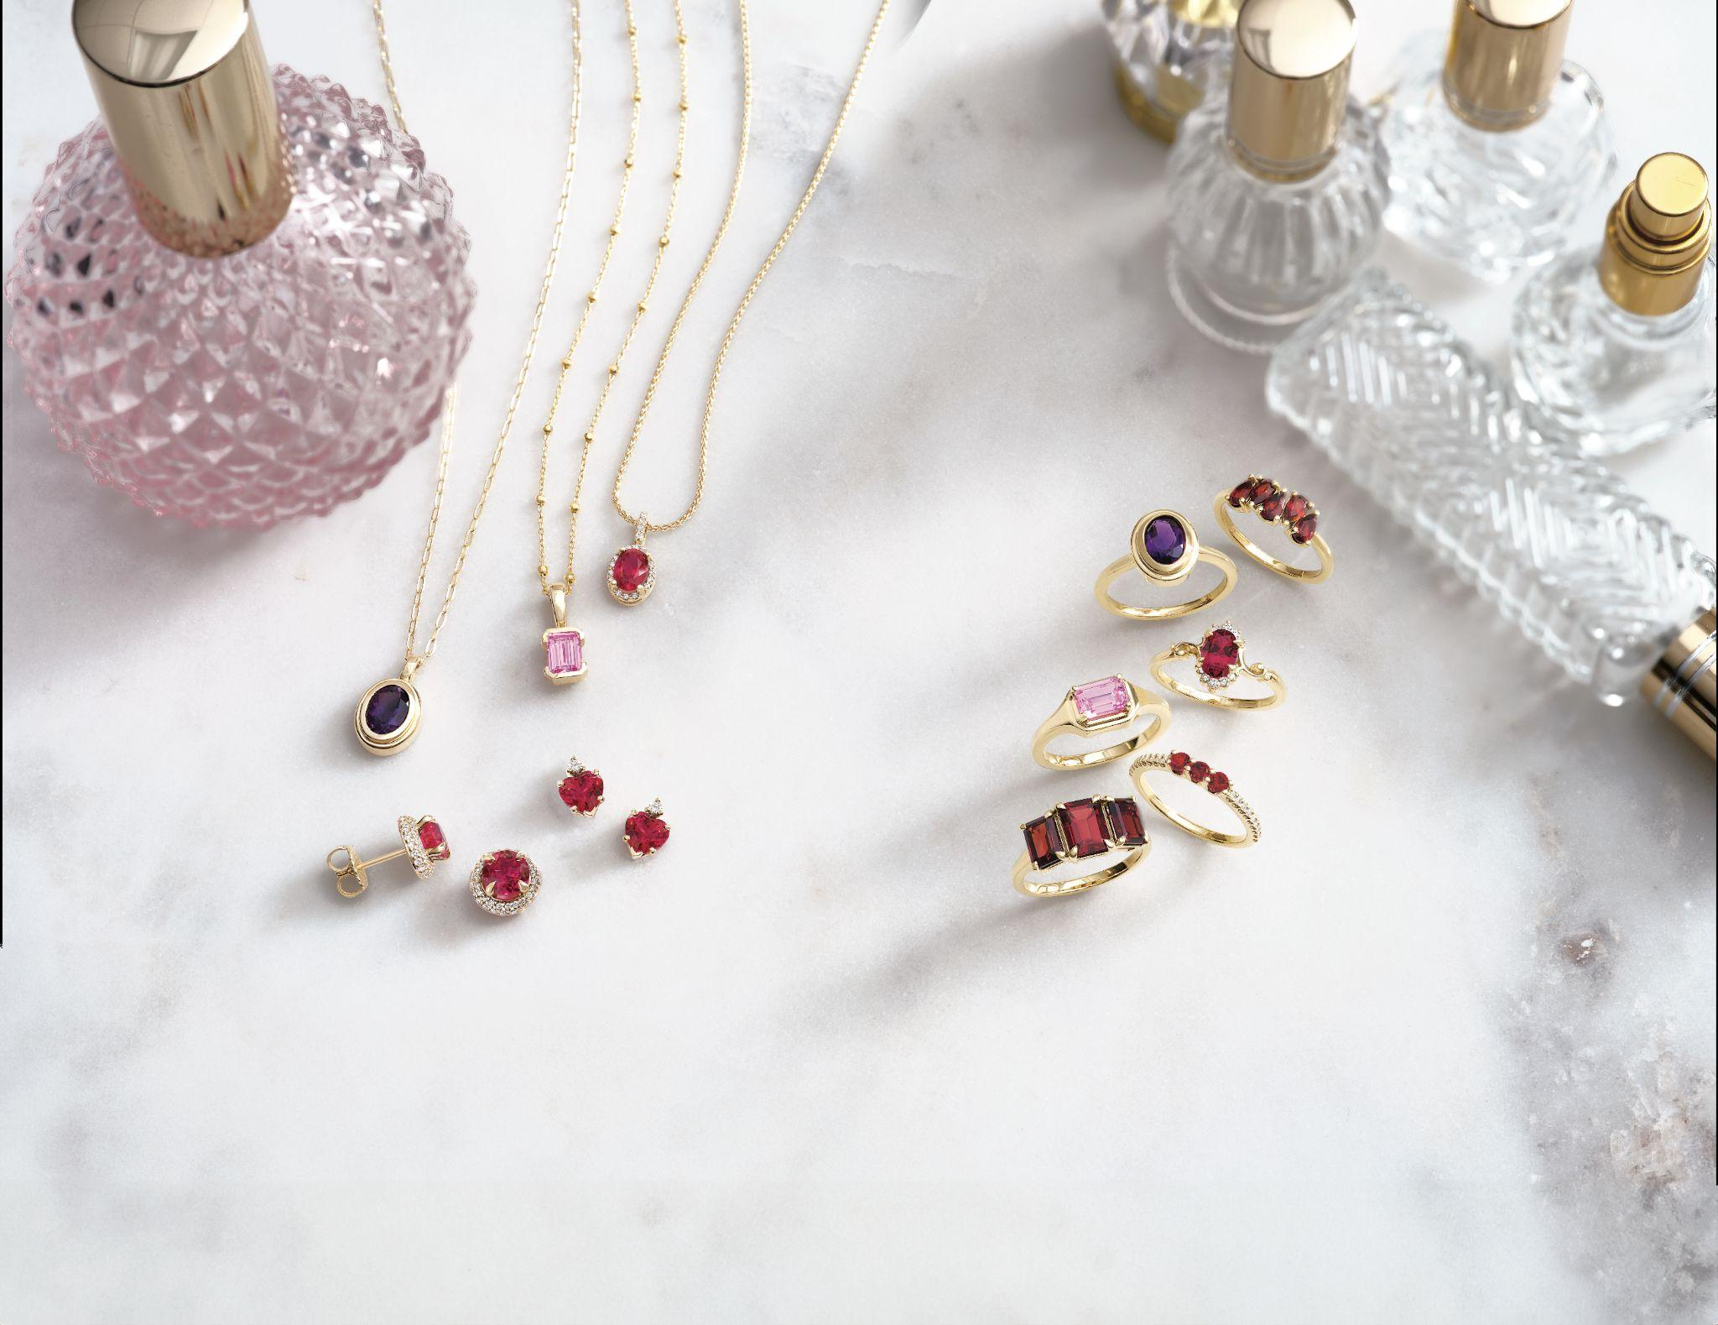

**These colorful accents pair beautifully with fall fashion and make perfect choices for special occasions like Thanksgiving or fall weddings. Whether as earrings, rings, or pendants, gemstone jewelry adds personality and warmth to your outfit.**

### **A Season of Dreams**

**Fall marks a shift from the bright tones of summer to deeper, richer hues—and with that comes fresh opportunities to redefine your style.**

**At Drenon Jewelry, we’re here to help you find the perfect pieces to complement your fall outfits and celebrations. We are artists crafting dreams, and we take pride in creating timeless looks that reflect your unique story.**